Use this reference to print your schedule.

INSTRUCTIONS
- Log into Workday and enter the Academics app.

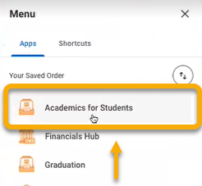

- Click the “Registration” tab.

- In the right-hand toolbar, click “View My Courses”.

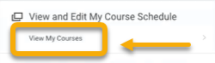

- On the View My Courses page, locate and click the small “PDF” icon in the top right-hand corner.

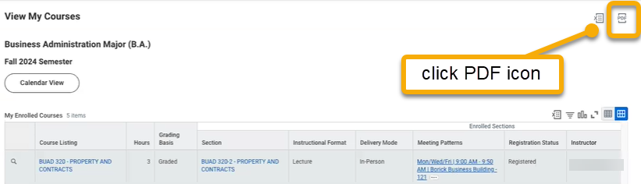

- The pdf will automatically download. When complete, click the “Download” button.

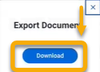

- Save the document to your preferred destination and print.

